**SC2006 Software Engineering**





Lab Group SSP1

Group Name: Depressed Elderly

Lab Supervisor: Liu Yang

| Group Members | |
| --- | --- |
| Name | Matriculation No. |
| Pan Shi Han Johnny | U2121697B |
| Bertranne Lee Zi - Wen | U2120209L |
| Yap Shen Hwei | U2140630E |
| Koh Jia Wei | U2121270D |
| Zhi Guang | U2120504C |
| Chong Yue Hong | U2120181D |

# 

**Complete Use Case Model** **4**

**Design Models** **5**

Class Diagrams 5

Sequence Diagrams 6

Create Account 6

Login 7

View Listing 8

Post Job 9

Edit Job 10

Delete Job 11

Accept Job 12

Retract Service 13

Rate User 14

Report To Customer Service 15

Report Emergency 16

Impose Penalty 17

Create Chatbox 18

Edit Account Information 19

Dialog Map 20

**System Architecture** **21**

**Application Skeleton** **22**

Login 22

Create Account 23

Landing Page 24

Profile Page 25

Editing Profile 26

Creating Job 26

Task Page 28

Job Information 29

Chat 29

Reporting 31

Rewards 32

**Appendix/ Footnote** **33**

# Complete Use Case Model

# 

# Design Models

## Class Diagrams

## 

## Sequence Diagrams

### Create Account

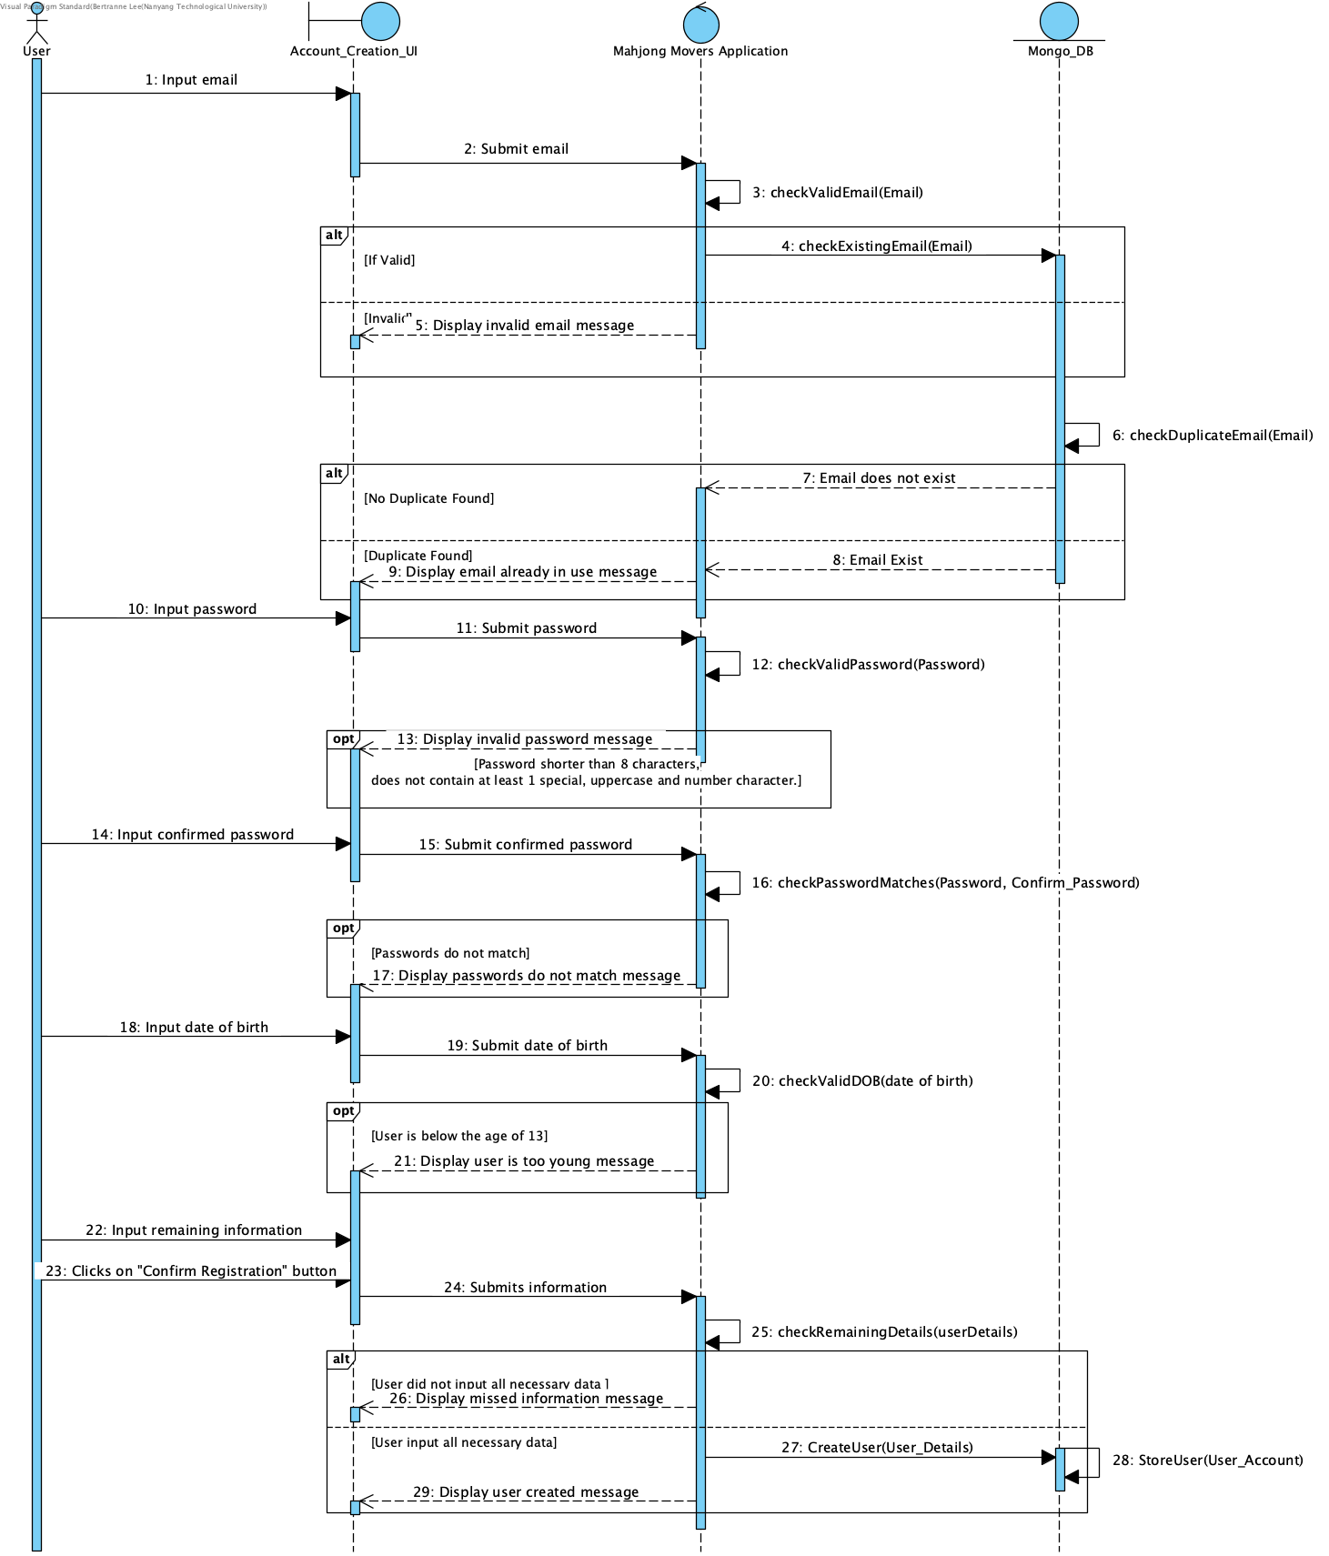

### 

### Login

### 

### View Listing

### 

### Post Job

### 

### Edit Job

### 

### Delete Job

### 

### Accept Job

### 

### Retract Service

### 

### Rate User

### 

### Report To Customer Service

### 

### Report Emergency

### 

### Impose Penalty

### 

### Create Chatbox

### 

### Edit Account Information

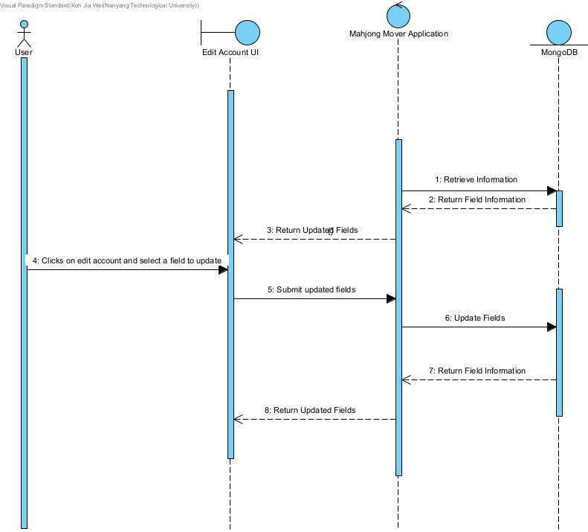

## 

## Dialog Map

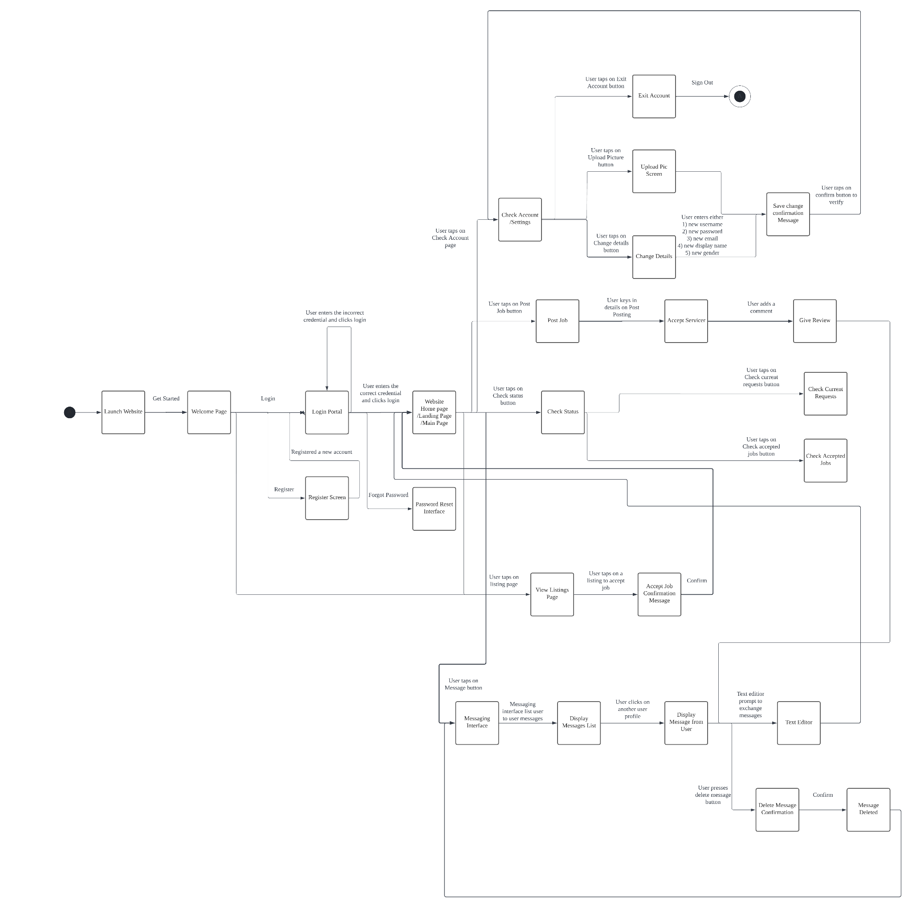

# 

# System Architecture

# 

# 

# Application Skeleton

## Login

## 

## Create Account

## 

## Landing Page

## 

## 

## Profile Page

## 

## 

## Editing Profile

## 

## 

## Creating Job

## 

## 

## Task Page

## 

## 

## Job Information

## 

## 

## Chat

## 

## 

## Reporting

## 

## Rewards

## 

# Appendix/ Footnote

For clearer and higher resolution images of our diagrams please refer to the files uploaded to either the github repository or the SVN.

## 